**Wilbur Wright College**

**CIS 282 – Web Dev IV**

**Final Project**

**Points:** 300

**Rubrics:**

Shopping cart functionality: 200 pts

Adding your own design css and graphics: 100 pts

**Objective:** Implement an NBA Shirt Shopping Cart System using the MVC framework. The System will include OOP development, Database Design, PHP Programming, HTML, CSS, Session Manipulation, etc.

**Description:**

1. This Project will be implemented in the root folder with the following features:
   1. View Products (with pagination), Add to Cart functionality (using Session ID as ID), See Cart.
   2. View Cart (showing all products in Cart), and Option to Check out, and Empty Cart.
   3. Check out creating the Invoice and Lineitem table.
2. Here the Database ERD:

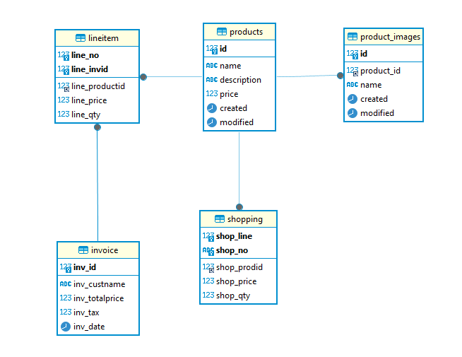

See the attached SQL file in the Project Description, CSS, and Database and Functions(OOP). Additionally, the Instructor will attach the Header file for all Pages and a zip folder with images.

1. You will implement all these files.
   1. Index.php: The controller to redirect actions.
   2. view.php: Landing file to show all products.
   3. cart.php: to view the Shopping Cart.
   4. checkout.php: to read Shopping cart and create invoice with Line items (it must delete all items in cart).
   5. invoice.php: to Show Final Invoice.
2. Here the screenshots (using my design):

view.php:

Page 1

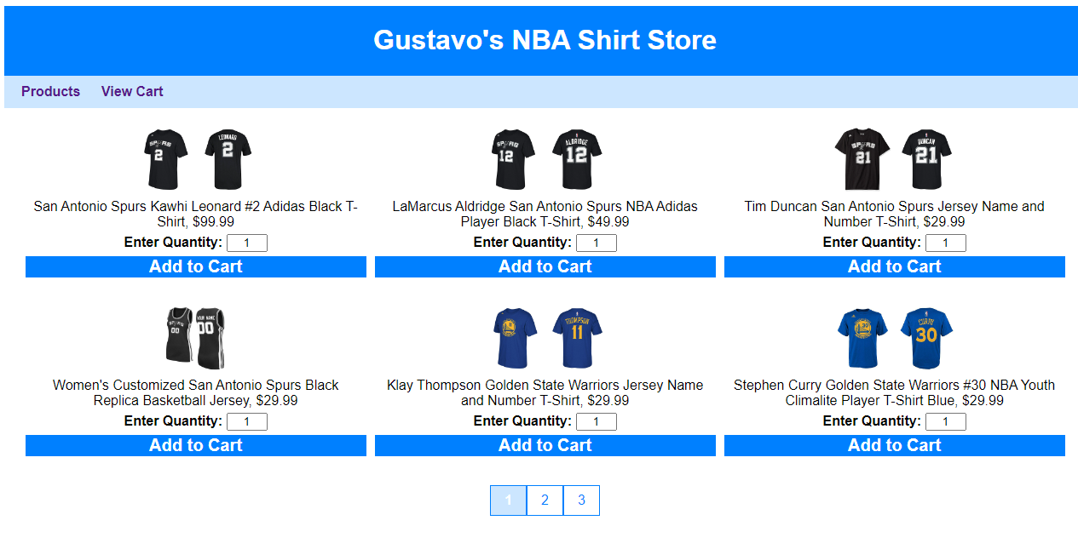

Page 2

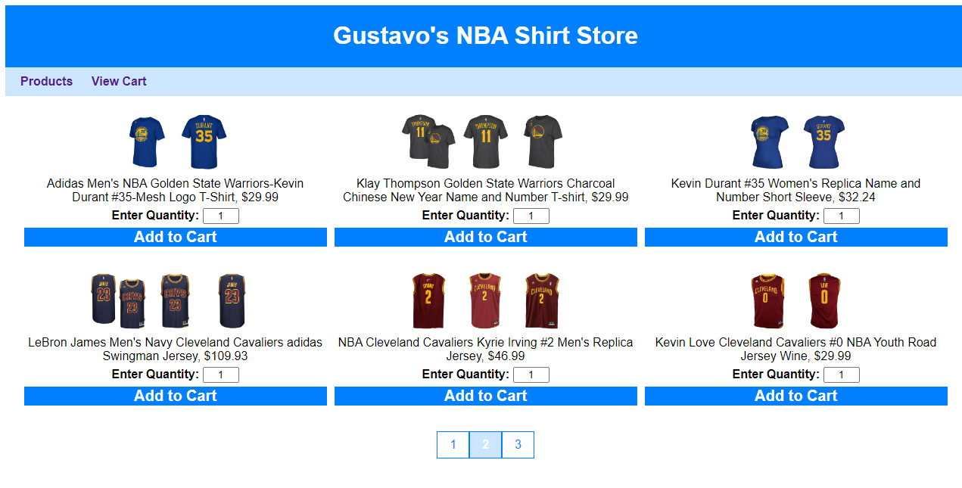

Page 3

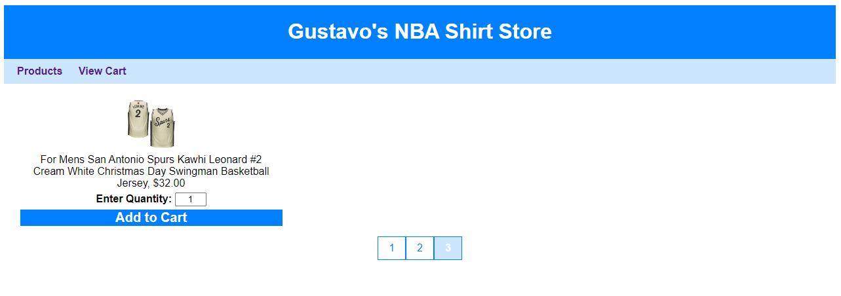

Adding Products to Shopping Cart:

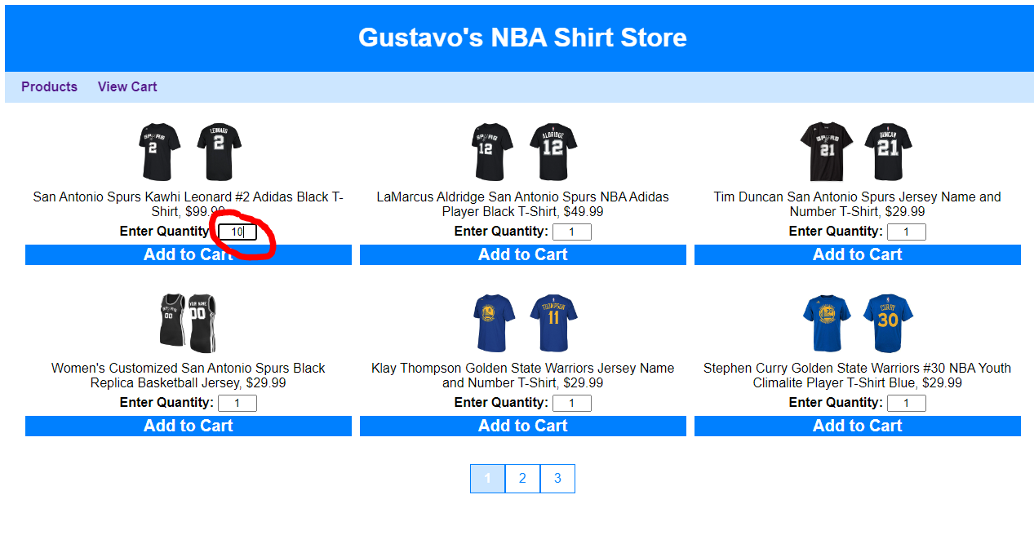

cart.php:

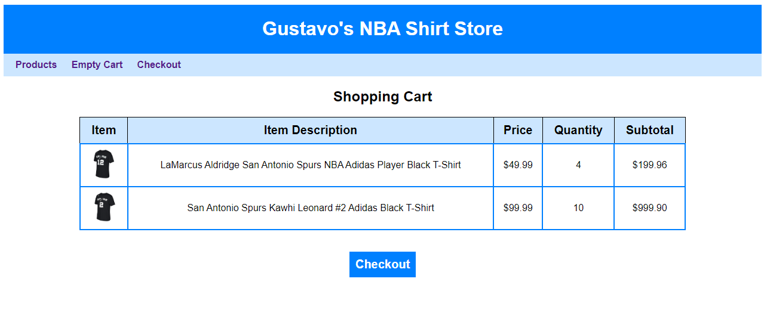

checkout.php:

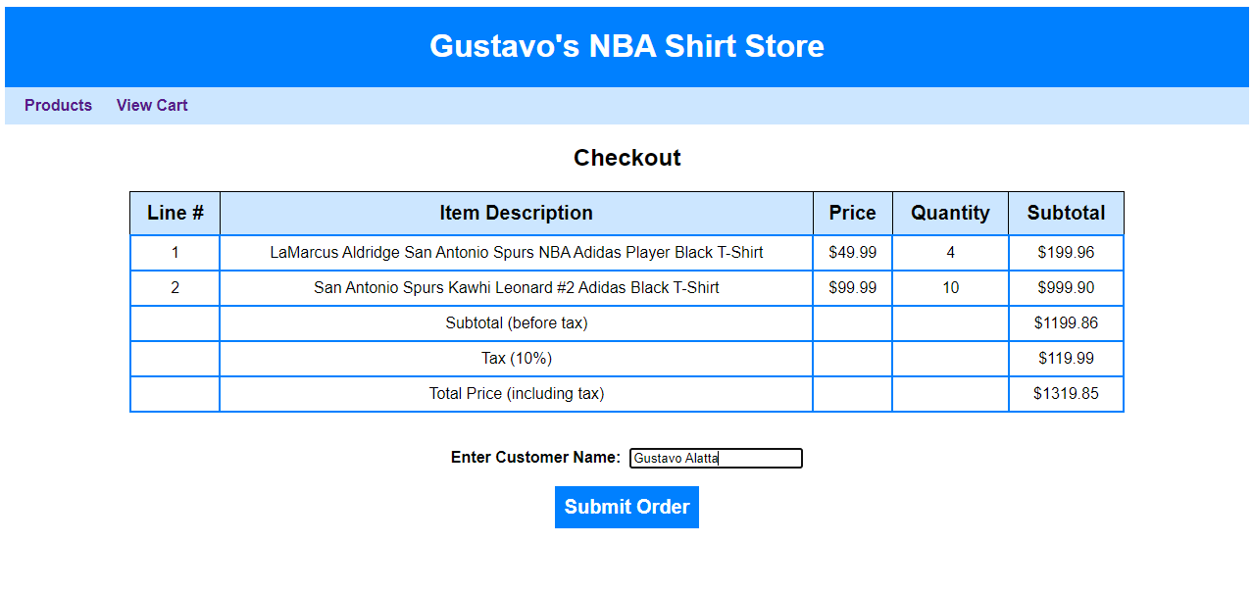

invoice.php:

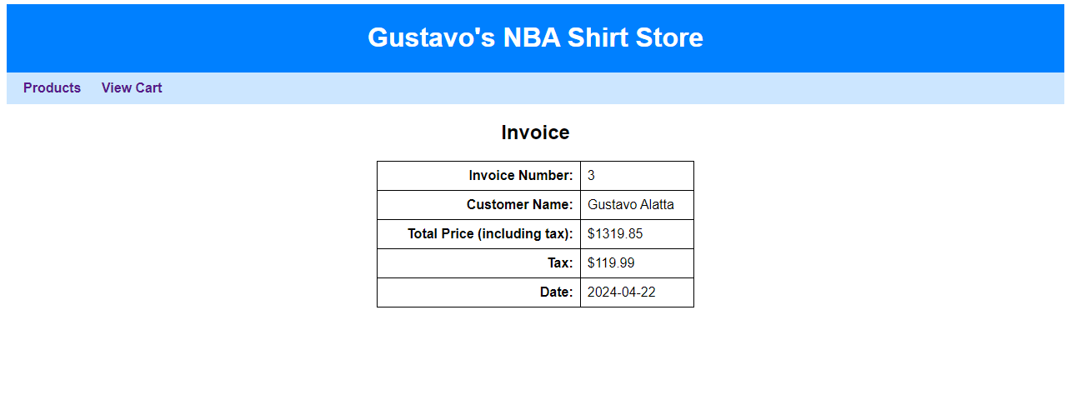

1. Create a Word Document (YourNameFinalProject.docx). Copy all your PHP in this document, add screenshots is the same document. include a zip folder with all your files. You will need to submit this Word Document in your Brightspace.